A Mini Project Report
On
LEAVE MANAGEMENT
Submitted in partial fulfillment of the
Requirements for the award of degree of
Bachelor of Technology
In
Computer Science and Engineering
By
AkshataKulkarni
(14H61A0563)
Akhila
(14H61A0595)
Sharath Chandra Telu
(14H61A05B1)

Under the Guidance of
Mrs. SRILATHA
Assistant Professor, CSE Dept.

ANURAG GROUP OF INSTITUTIONS
(Formerly CVSR College of Engineering)
(An Autonomous Institution, Approved by AICTE and NBA Accredited)
Venkatapur (V), Ghatkesar (M), RR Dist., T.S-500088
(2014-2018)
Department of Computer Science and Engineering



CERTIFICATE

This is to certify that the project entitled “LEAVE MANAGEMENT” being submitted by Akshata bearing the Hall Ticket number 14H61A0563,M Akhila bearing the Hall Ticket number 14H61A0595 and Sharath Chandra Telu bearing the Hall Ticket number 14H61A05B1 in partial fulfillment of the requirements for the award of the degree of the Bachelor of Technology in Computer Science and Engineeringto Anurag Group of Institutions(FormerlyCVSR College of Engineering) is a record of bonafide work carried out by them under my guidance and supervision from May 2017 to Oct 2017.
The results presented in this project have been verified and found to be satisfactory. The results embodied in this project report have not been submitted to any other University for the award of any other degree or diploma.

Internal Guide External Examiner
Mrs.Srilatha
Assistant Professor

Project Coordinator
Pallam Ravi
Assistant Professor
Dr.G.Vishnu Murthy
Deputy Director and Head of Department, CSE
ACKNOWLEDGEMENT

It is our privilege and pleasure to express profound sense of respect, gratitude and indebtedness to our guide Mrs. Srilatha, Assistant professor, Dept. of Computer Science and Engineering, Anurag Group of Institutions (Formerly CVSR College of Engineering), for her indefatigable inspiration, guidance, cogent discussion, constructive criticisms and encouragement throughout this dissertation work.
We express our sincere gratitude to Dr. G.Vishnu Murthy, Professor & Head, Department of Computer Science and Engineering, Anurag Group of Institutions (Formerly CVSR College of Engineering), for his suggestions, motivations and co-operation for the successful completion of the work.
We extend our sincere thanks to Dr.K.S.Rao, Director, Prof.M.BhagvanthRao, Director, Dr.V.Vijaya Kumar, Dean, Dept. of CSE & IT, Anurag Group of Institutions (Formerly CVSR College of Engineering), Venkatapur (V), Ghatkesar (M), Ranga Reddy (Dist), for their encouragement.

Akshata K
(14H61A0563)
Akhila
(14h61a0595)
Sharath Chandra Telu
(14H61A05B1)

DECLARATION

We hereby declare that the project work entitled “ Leave Management” submitted to the Anurag Group of Institutions(Formerly CVSR College of Engineering) in partial fulfillment of the requirements for the award of the degree of Bachelor of Technology (B.Tech) in Computer Science and Engineering is a record of an original work done by us under the guidance of Mrs. Srilatha, Assistant Professor and this project work have not been submitted to any other university for the award of any other degree or diploma.

Akshata K (14H61A0563)
Akhila (14h61a0595)
Sharath Chandra Telu(14H61A05B1)

Date: 25/10/2017

CONTENTS
Abstract i
List of Figures ii
List of Tables ii
List of Abbreviations ii
Page No
- INTRODUCTION 2
  - Scope 2
  - Existing System 2
  - Proposed System 2
  - Functionalities 3
  - Module Description 4
  - Analysis 5
  - Software Requirements 5
  - System Requirements 5
  - Activity Diagram 6
- SOFTWARE REQUIREMENTS SPECIFICATION 8
  - Usecase Diagram for each Actor 9
  - Program Files 12
  - Parameters and User Manual 13
- DATABASE/E-R DIAGRAM 28
- TESTCASES 32
- DEPLOYMENT 33
- CONCLUSION 34
  - Project Conclusion 34
  - Future Enhancements 34

REFERENCES 41

LIST OF FIGURES
FIGURE NO NAME PAGE NO
1.1 Activity Diagram 7
2.1.1 Usecase Diagram 9
2.1.2 Usecase Diagram for User 10
2.1.2 Usecase Diagram for Admin 11
2.1.3 Usecase Diagram for Dealer 12
2.3.1 Index 13
2.3.2 Registration 14
2.3.3 User Login 16
2.3.4 User Header 18
2.3.5 User Upload Form 23
2.3.6 User Search 26
3.1 E-R Diagram 28
5.1 Deployment Diagram 33

LIST OF TABLES
TABLE NO NAME PAGE NO
2.1. Actors in Usecase Diagram 8
3.1 Users Table 29
3.2 Admin Table 29
3.3 User Plots Table 30
3.4 HOD Table 31
4.1 Testcases 32

LIST OF ABBREVIATIONS
- HTML : Hyper Text Markup Language
- URL : Uniform Resource Locator
3. PHP : Hypertext Preprocessor
- UML : Unified Modeling Language

ABSTRACT
The “Online Leave Report Management System” is user friendly website.The main objective of the project is to decrease the paperwork of the institution. It is convenient to implement and easy to understand.The need of designing such website is to provide administration better way for scheduling and balancing workload by maintaining leave details of the employees. It reduces the human effort of checking papers for leave request manually and maintaining it in folders and files.In this system, collection of data and storage of data is done faster and there is opportunity for easy reference. This system will provide users with complete record of leaves. The project includes employee login and admin login and hod login. Employee login enable the employees to apply leave,check their leave status and also cancel the leave.The hod login enables the hod to approve or decline the leave applied by the employees.Admin login enables to view the details of the employees.
The Online Leave Report Management has the feature of mobile compatibility by which the employees can apply leave online through internet anytime and anywhere with mobile instead of manually writing the formal leave letter. The interface is very user- friendly. This project is being developed by My SQL and PHP.
This project is aimed at developing an online leave management system that is of importance to the institution. The Leave Management System (LMS) is an Internet based application that can be accessed throughout the institution or a specified group/Dept. This system can be used to automate the workflow of leave applications and their approvals. The system is thus helpful to reduce the time and complexity of maintaining the record.

CHAPTER-1
INTRODUCTION
1.1 SCOPE
This project helps the employees to apply leave online as there is the option of mobile compatibility.It is totally helpful for the institution as it reduces the paper work amd complexity of maintaining the records.It also allows the employees to check the status of the leave.This also allows the employees to cancel the applied leave,in this way it is very portable and easy to apply leave instead of manually writing the leave letter.

1.2 EXISTING PROJECT:
In existing system every college follows manual procedure in which faculty should enter in time and out time in a record book. At the end of each month Head of department will calculate leaves of every faculty which is a time taking process and there is chances of losing records.
DISADVANTAGES OF EXISTING PROJECT:
- Maintainance of manual records is difficult.
- There is a chance of error.
1.3 PROPOSED PROJECT:
In proposed system chances of losing data is not possible because data is maintained in the form of database. Every day attendance, leaves and notices information is updated in to database using a user friendly GUI. This will reduce work for Head of departments. This application is an online application which makes more flexible to access information.
.The need of designing such website is to provide administration better way for scheduling and balancing workload by maintaining leave details of the employees.It reduces the human effort of checking papers for leave request manually and maintaining it in folders and files.
In this system ,collection of data and storage of data is done fast and there is opportunity for easy reference.The system will provide users with complete record of leaves..The system is thus helpful to reduce the time and complexity of maintaining the record.
1.4 FUNCTIONALITIES OF THE SYSTEM:
Following is a list of functionalities of the system:
A person should be able to
  - login to the system through the first page of the application
  - see his/her eligibility details (like how many days of leave he/she is eligible for etc)
  - apply for leave, specifying the from and to dates, and reason for taking leave
  - see his/her current leave applications and the leave applications that are submitted
  - approve/reject the leave applications that are submitted to hod

1.5 MODULE DESCRIPTION

Number of Modules:
After careful analysis the system has been identified to have the following modules:

- Admin Module
- Employee Module
- Hod Module
- Principal Module

1. Admin Module:
Admin will maintain all the student details, student leave record details, in the database.
2. Student Module:
In this module student will register their daily attendance information like leave approvals and new notifications. Student should log in to their account and update information. If there are any notifications related to previous day it is displayed in the form of pop up. Students should respond to that notification by sending reply to higher authorities.
3. HOD Module:
In this module Head of the department will have permissions to look after data of every student member of their department. HOD can view data in the form of reports and get it
form of print out. Reports can be displayed based on day, month. HOD can approve leave through this application and he can view leaves information of every individual
4.Principal Module:
Among the entire modules principle module is given more permission. He can view information of every departments student information and take action based on the reports. Principle can view information like student member’s leaves, attendance and notifications including Head of departments. He can print reports on daily or monthly basis. In this module Leave approval and resignation are included.

Advantage:
The institution will obviously be able to gain benefits such as savings in operating cost, reduction paper work, better utilization of human resources and more presentable image increasing goodwill. The other benefits are improved service and faster and better access to up to date information.

1.6 ANALYSIS
INTRODUCTION
Analysis is done in such a way that, it becomes easier to provide the services needed to the employees. The whole web application is made in the thought of helping our college, with the easier way to keep the track records about the services they are providing the employees.

1.7 SOFTWARE REQUIREMENT AND SPECIFICATION:
Users of your system:
The users of this system are:
- Students: Undergraduates/Graduates/Postgraduates etc.
- Academicians
- Professional Organizations
- Employees
User Functionalities:
The common feature for all employee is to login to their accounts to access all the features.
They have to explain the exact reason for the leave.
The employee can also check the status of the leave.
The employee can cancel the applied leave.
User’s Functionalities Scenario :
Scenario : Faculty A has visited the company website in order to check for the number of leaves in the account..Firstly A can login as he is an existing user using his credentials or simply signup if he is a new user and select reason for his leave. Then, all his balance leaves will be shown.

1.8 SYSTEM REQUIREMENTS:
HARDWARE REQUIREMENTS:

- Operating System : Windows
- Technology : PHP
- Web Technologies : Html, JavaScript, CSS
- IDE : Notepad++
- Web Server : Wamp2.2e
- Database : My SQL

SOFTWARE REQUIREMENTS:

- Hardware - Pentium
- Speed - 1.1 GHz
- RAM - 1GB
- Hard Disk - 20 GB
- Floppy Drive - 1.44 MB
- Key Board - Standard Windows Keyboard
- Mouse - Two or Three Button Mouse
- Monitor - SVGA

1.9 ACTIVITY DIAGRAM:

Activity diagram is another important diagram in UML to describe dynamic aspects of the system. Activity diagram is basically a flow chart to represent the flow form one activity to another activity. The activity can be described as an operation the of system. So the control flow is drawn from one operation to another.These diagrams are graphical representations of workflows of stepwise activities and actions with support for choice, iteration and concurrency.

DESCRIPTION:
The activity diagram shows the workflow of the activities involved in the system.This system consists of three logins namely admin,hod and employee.The employee can apply leave,view his applied leave,view the status of the leave and also can cancel his applied leave.The hod can view the leave requested employees and approve or decline the leave.The admin can view the details of the leave applied employees.As all of them have their independent logins,they can logout after performing their actions.

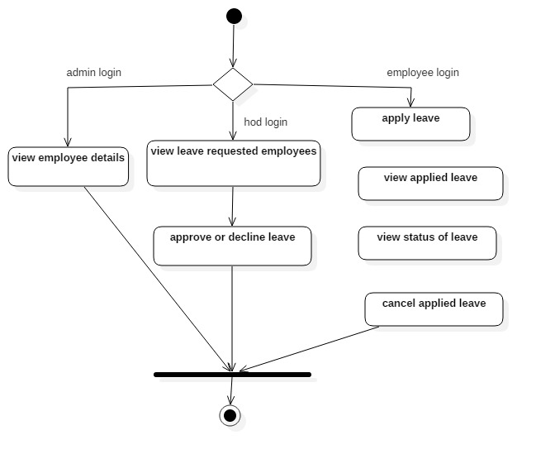

Fig.1.1.Activity Diagram

CHAPTER-2
SOFTWARE REQUIREMENTS SPECIFICATIONS

ACTORS:
An actor is behaviored classifier which specifies a role played by an external entity that interacts with the subject (e.g., by exchanging signals and data), a human user of the designed system, some other system or hardware using services of the subject.
The term "role" is used informally as some type, group or particular facet of users that require specific services from the subject modeled with associated use cases. When an external entity interacts with the subject, it plays the role of a specific actor. That single physical entity may play several different roles, and a specific role may be played by single instances.

ACTORS IN THE PROJECT:

- Employee
- Hod
- Admin

ACTORS | DESCRIPTION
EMPLOYEE | - Employee can apply leave  - Employee can view his applied leave  - Employee can cancel applied leave  - Employee can check status of applied leave
HOD | - Hod can view the leave applied employees.  - Hod can accept or reject the leave applied by the employees.
ADMIN | - Admin can view all the leave applied employees.  - Admin can edit or delete the employee details.
2.1 USECASE DIAGRAM:
A use case diagram at its simplest is a representation of a user’s interaction with the system and depicting the specifications of a use case. A use case diagram can portray the different types of users of a system and the various ways that they interact with the system. This type of diagram is typically used in conjunction with the textual use case will often be accomplished by other types of diagrams as well.

USECASE DIAGRAM FOR EMPLOYEE:
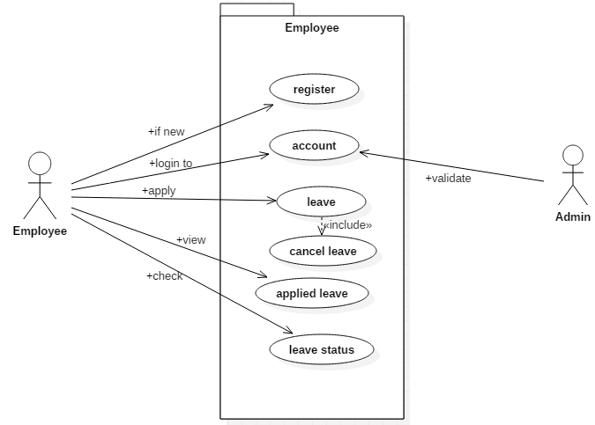

In the above use case diagram there is one actor and six usecases.
- Actor: employee
- This usecase diagram depicts the functions of the employee like
- registration,
- login,
- application of leave,
- viewing the applied leave,
- viewing the leave status and
- leave cancellation.

USECASE DIAGRAM FOR HOD:
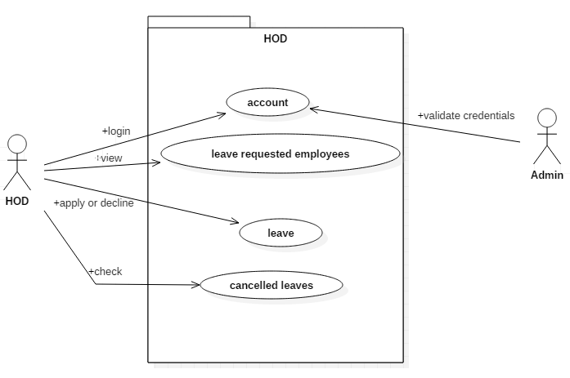

In the above use case diagram there is one actor and four usecases.
- Actor: hod
- This usecase diagram depicts the functions of the hod like
- login,
- view leave requested employees
- approve/decline leave
- view leave cancelled employees

USECASE DIAGRAM FOR ADMIN:

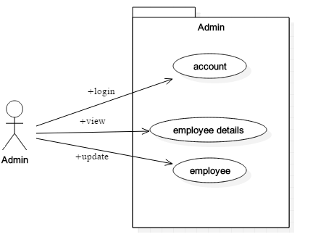

In the above use case diagram there is one actor and four usecases.
- Actor: admin
- This usecase diagram depicts the functions of the admin like
- login,
- view employees details

FINAL USECASE DIAGRAM:
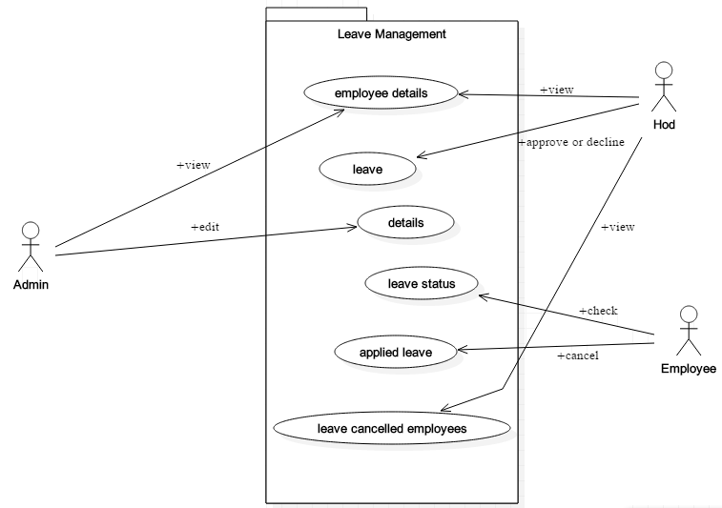

2.2 PROGRAM FILES
We have the following programming files in our project.
- index.html
- registration.php
- login.php
- leave.php
- leaveapplication.php
- viewappliedleave.php
- leavecancellation.php
- emphome.php
- hodhome.php
- mlink.php
- hodlogin.php
- adminlogin.php
- alink.php

2.3 PARAMETERS AND USER MANUAL
index.php
Parameters : none
Itcontains the code for home page of the website consists of employee login, hod login and admin login.
Employee Manual:
Employee can select: register
Employee can select: login
Hod Manual:
hod can select: login
Admin Manual:
Admin can select: login

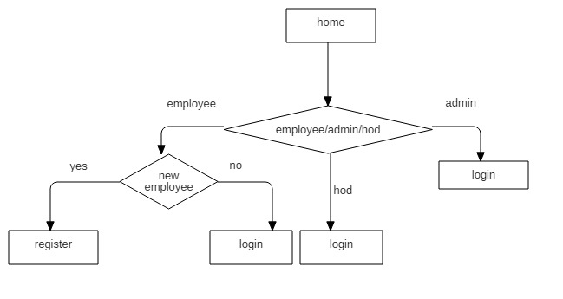
Fig.2.3.1.Index

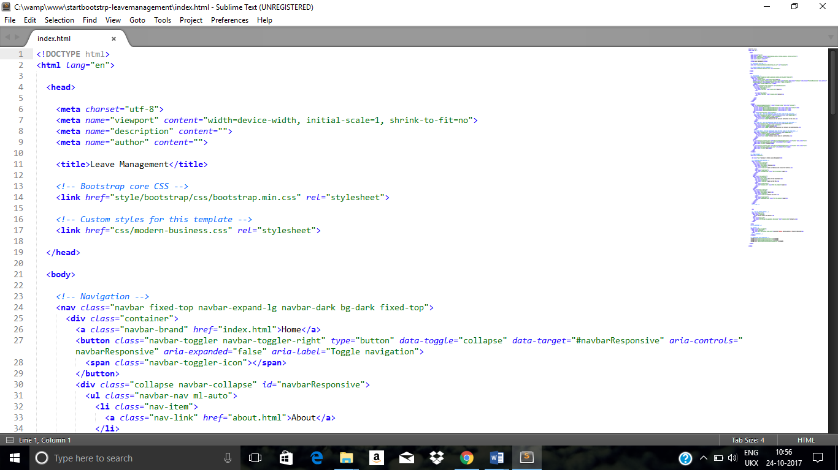

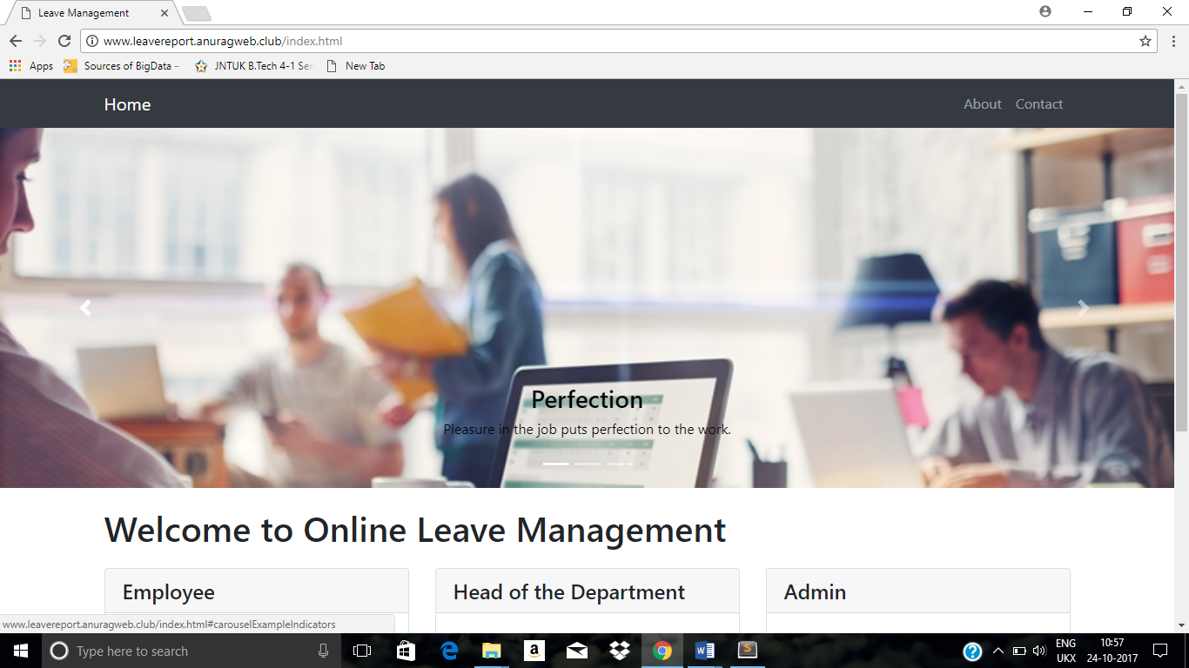

Registration.php
Parameters :username,firstname,lastname,password,email
This file makes the employee to register with his/her personal details. They are asked to provide some sort of credentials (such as username, e-mail and password) to the system in order to prove their identity.
Employee Manual : employee provides all the details Register
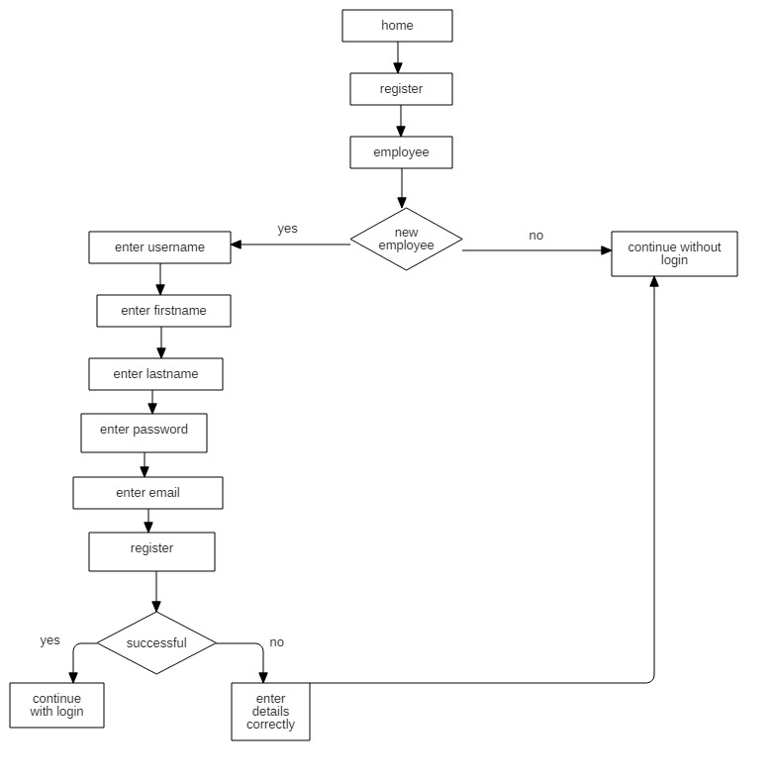
Fig.2.3.2.Registration

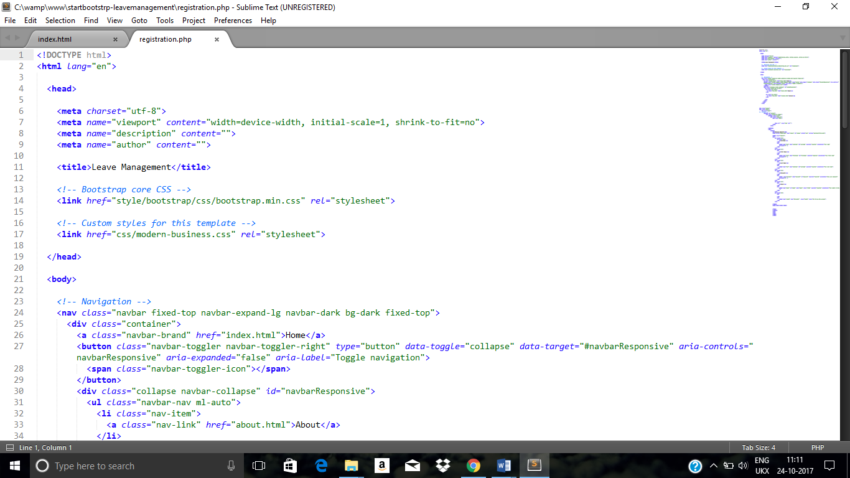

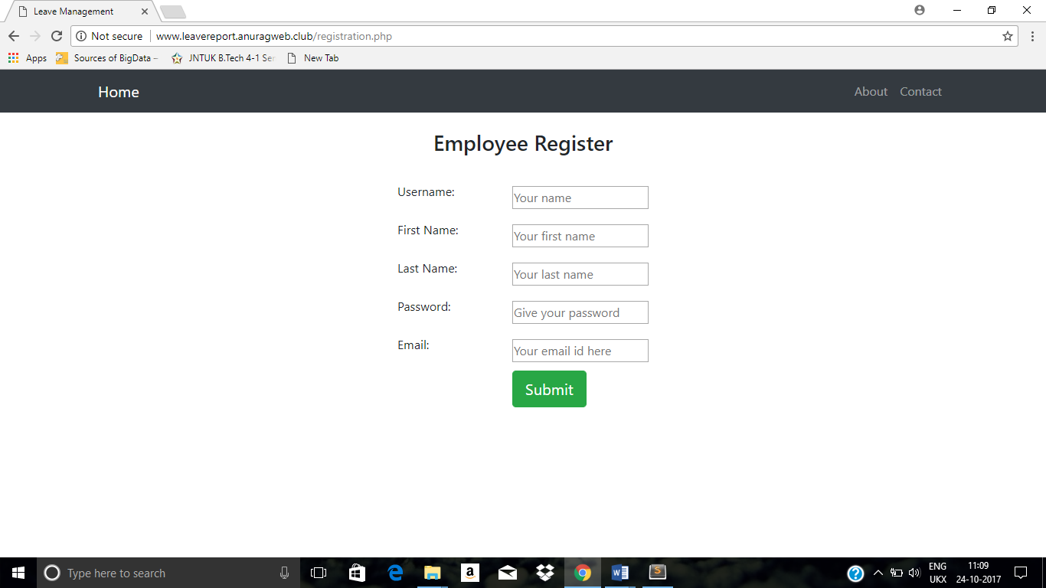

Userlogin.php
Parameters :Username, Password
This file makes the registered employee to login with his/her username and password.
User Manual :User enters the username and password Login
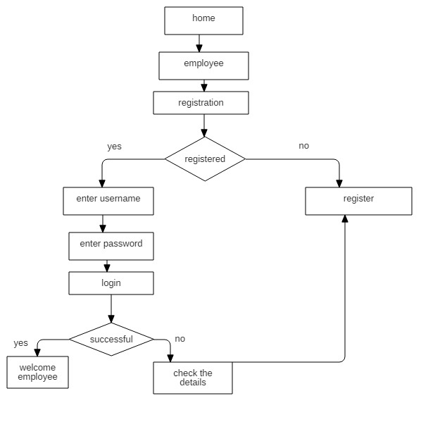
Fig.2.3.3.Userlogin

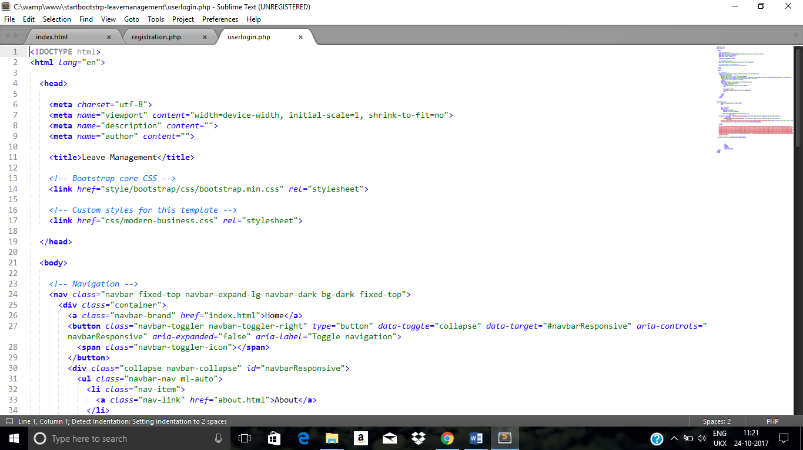
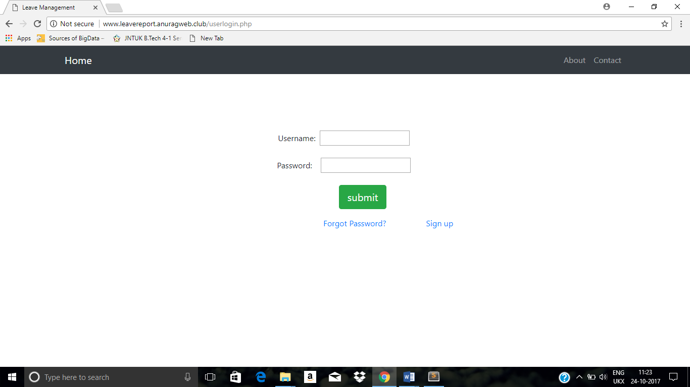

Leave.php:
Parameters :none
This file makes the registered employee to apply leave,view applied leave and cancel the applied leave.
Employee Manual : employee enters the details to apply leave

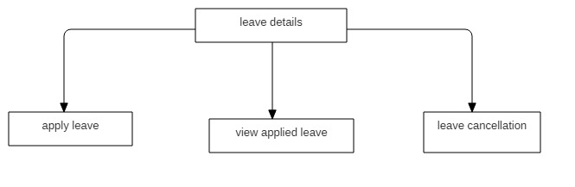
Fig.2.3.4.Registration

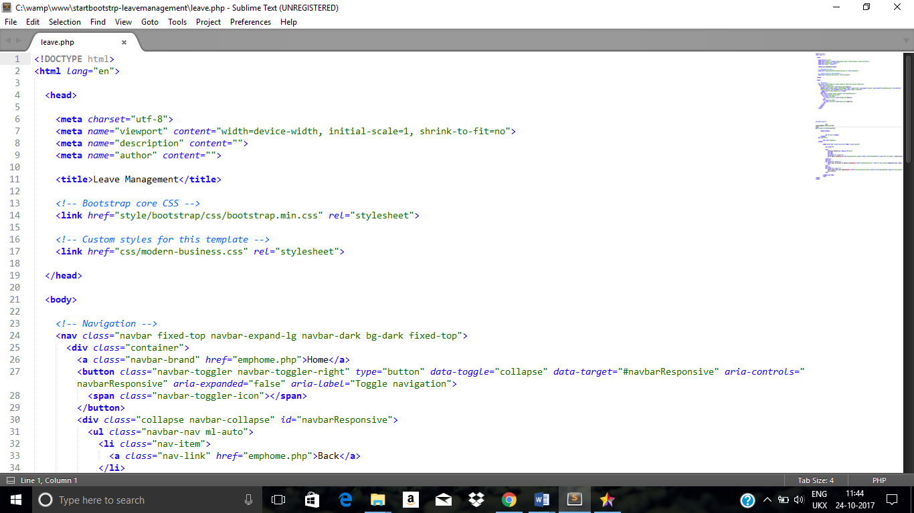

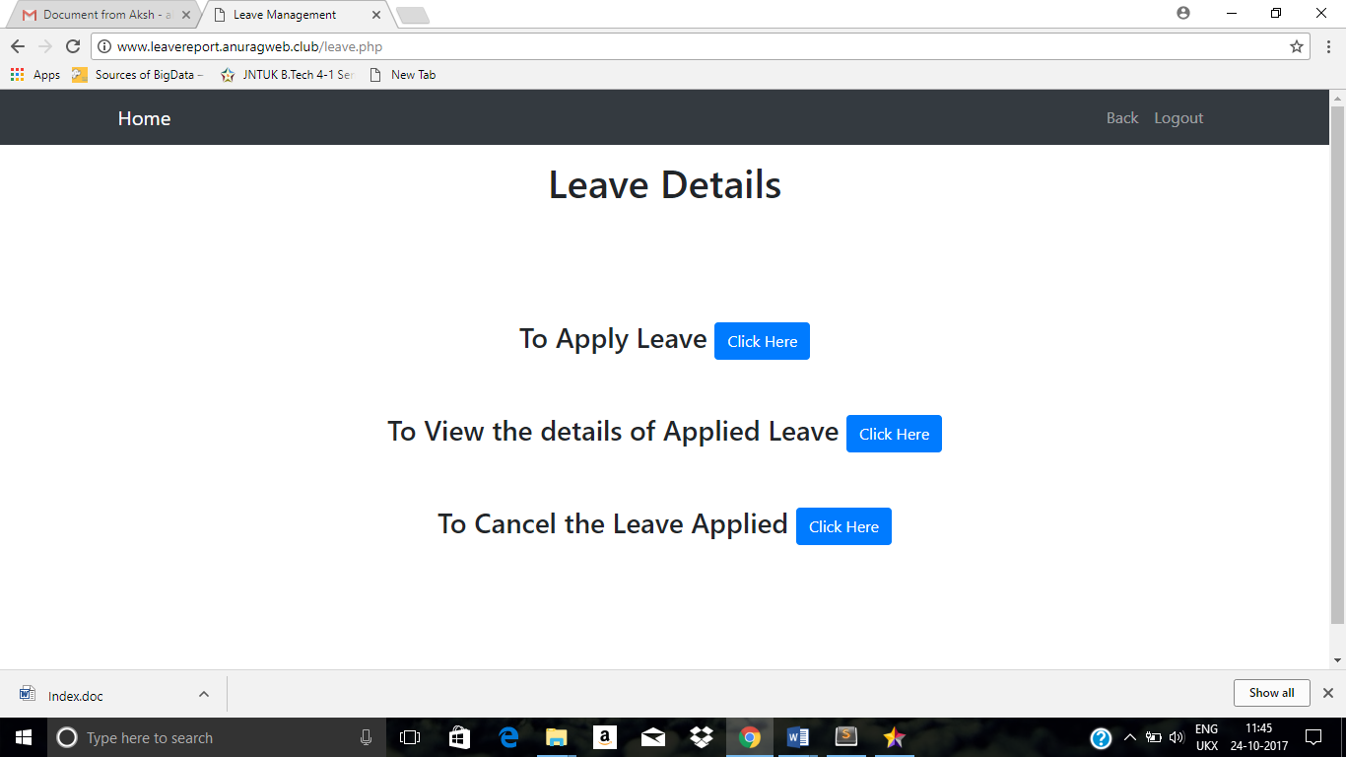

lea

Leavestatus.php
Parameters :none
This file makes the registered employee to view the status of the leave.
Employee Manual : employee enters the details to apply leave
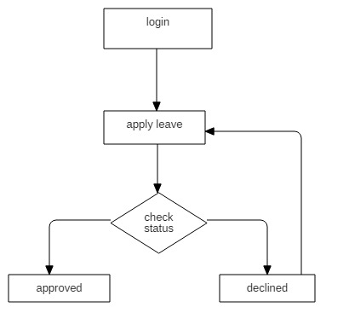

Fig.2.3.5.Registration
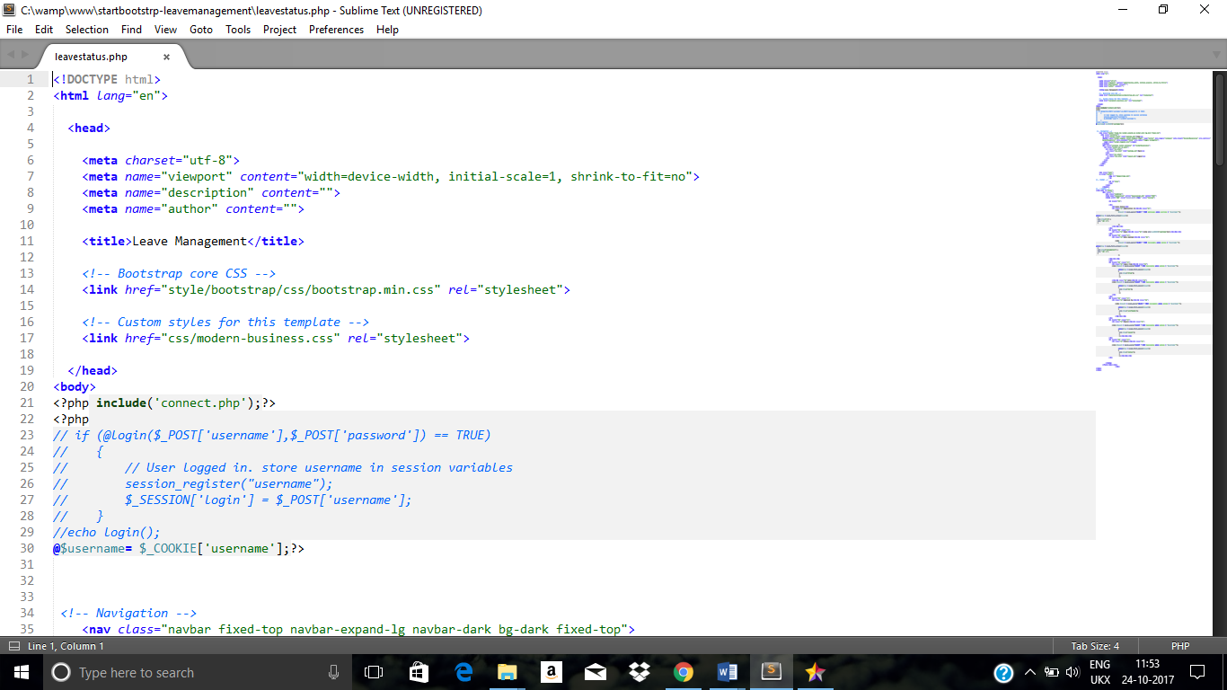

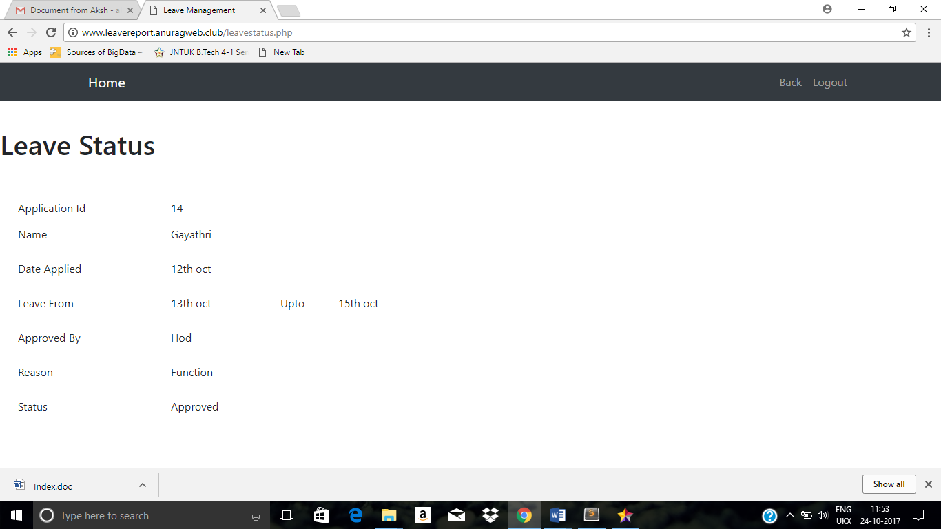

Leaverequest.php
Parameters :none
This file allows the hod to view leave requested employees and to approve or reject their leave.
Hod Manual:
hod can approve leave
Hod can decline leave
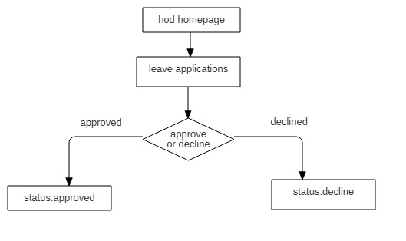
Fig.2.3.6.Registration

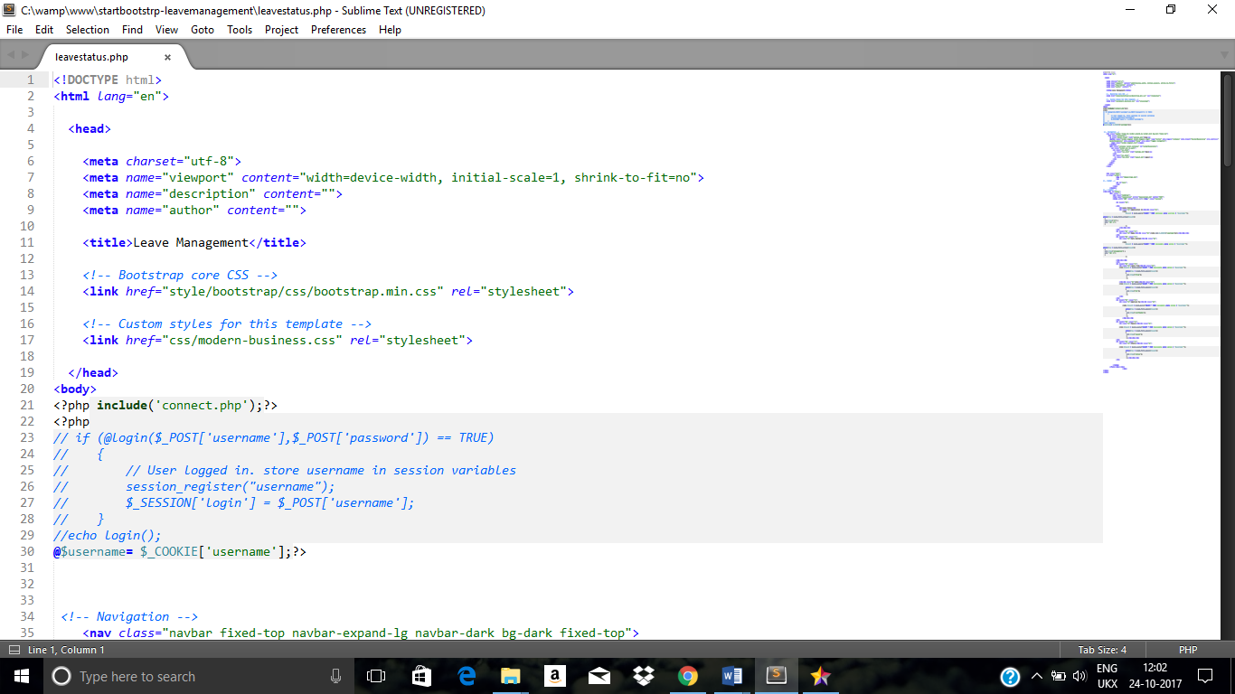
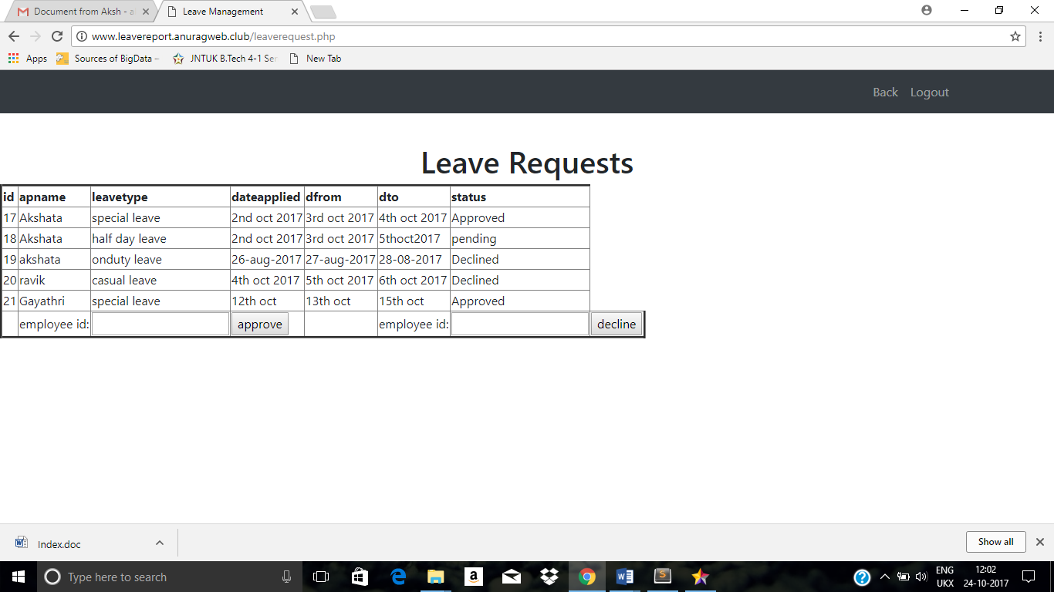

Approve.php
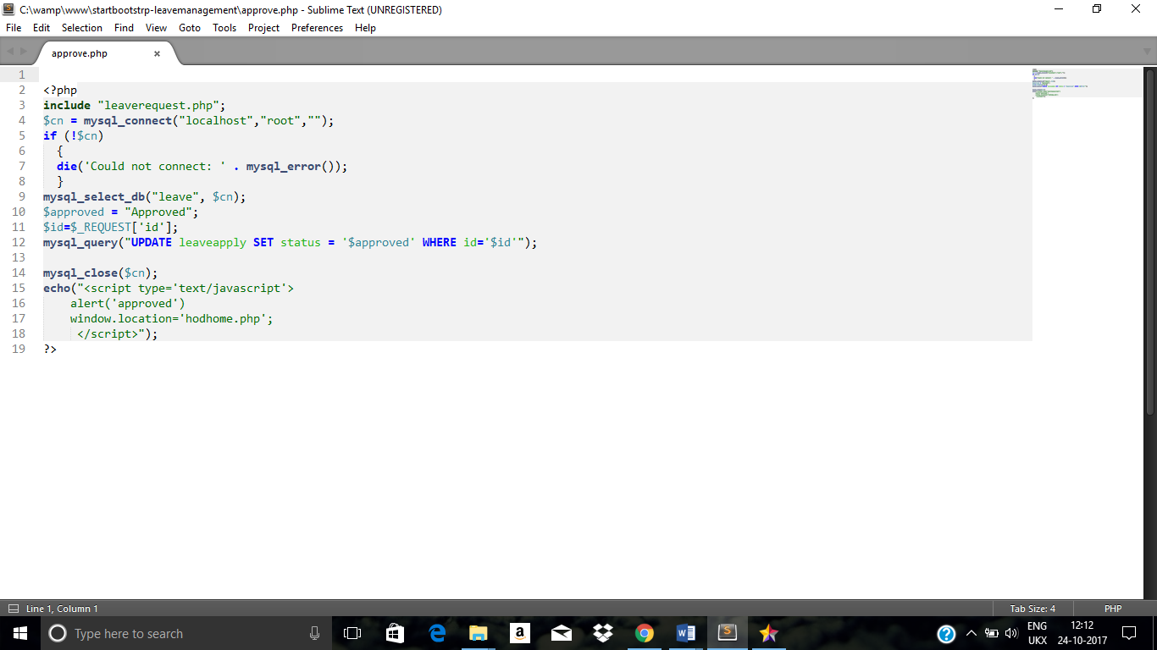
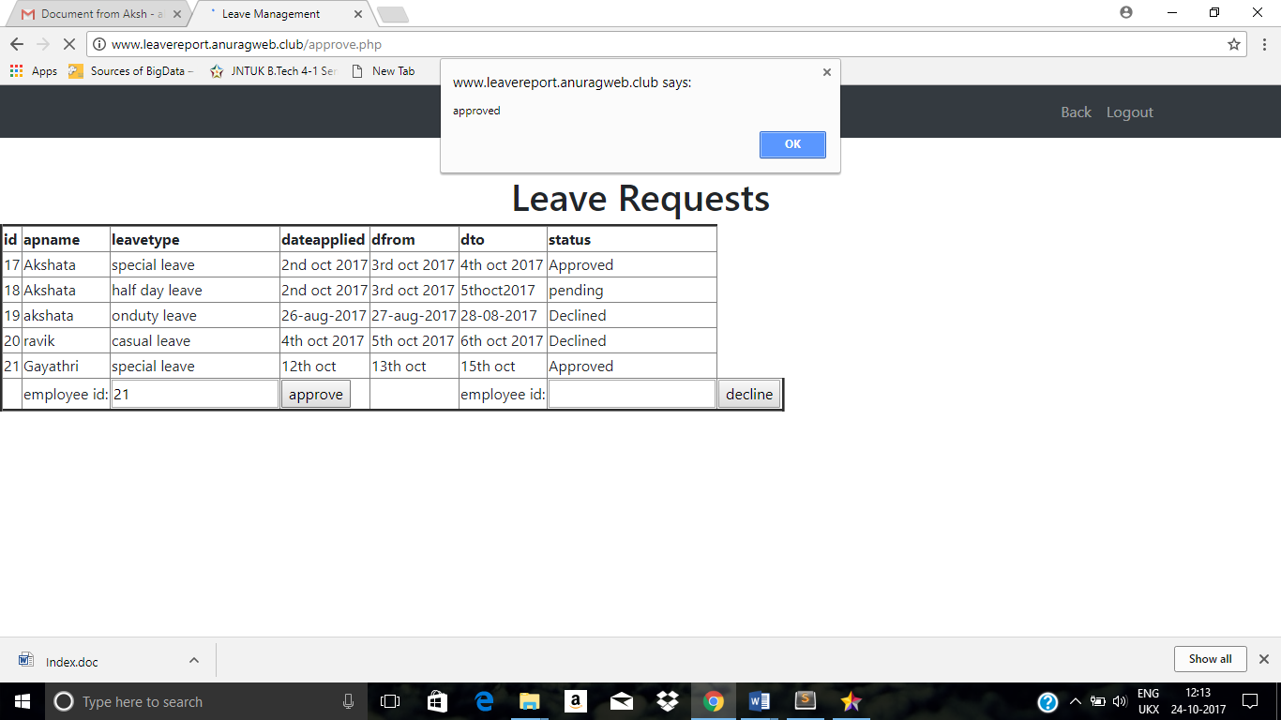

Decline.php:
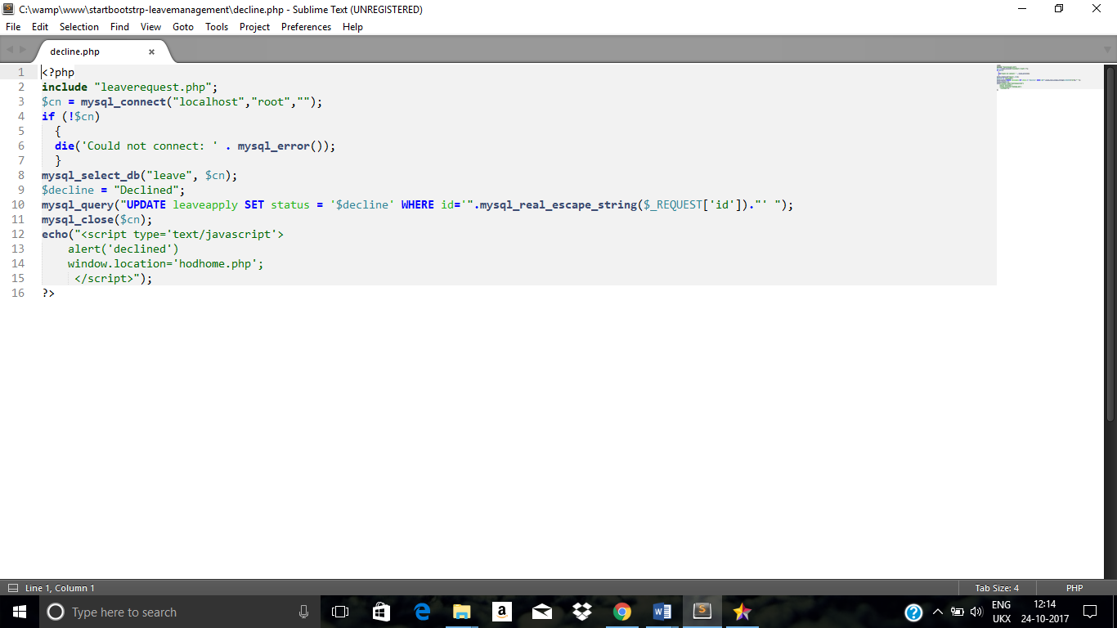
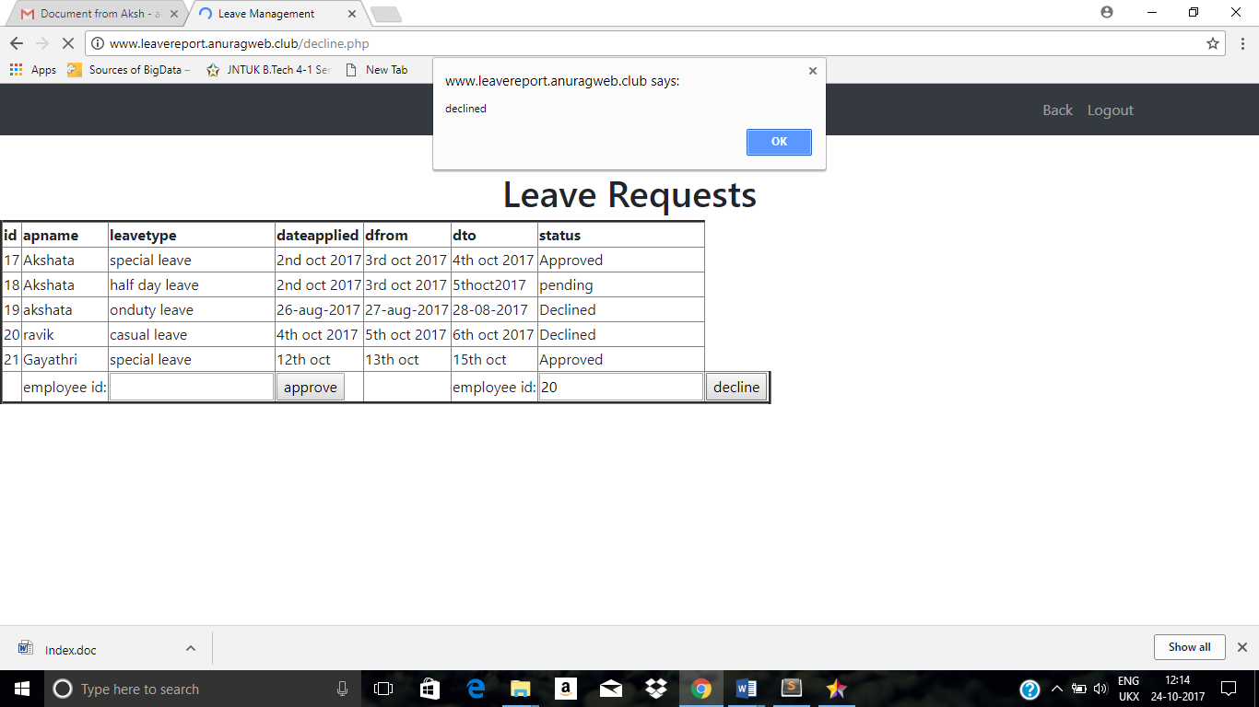

Employees.php
Parameters :none
This file allows the admin to view the employee details .

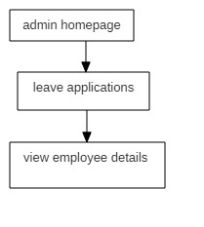
Fig.2.3.7.Registration

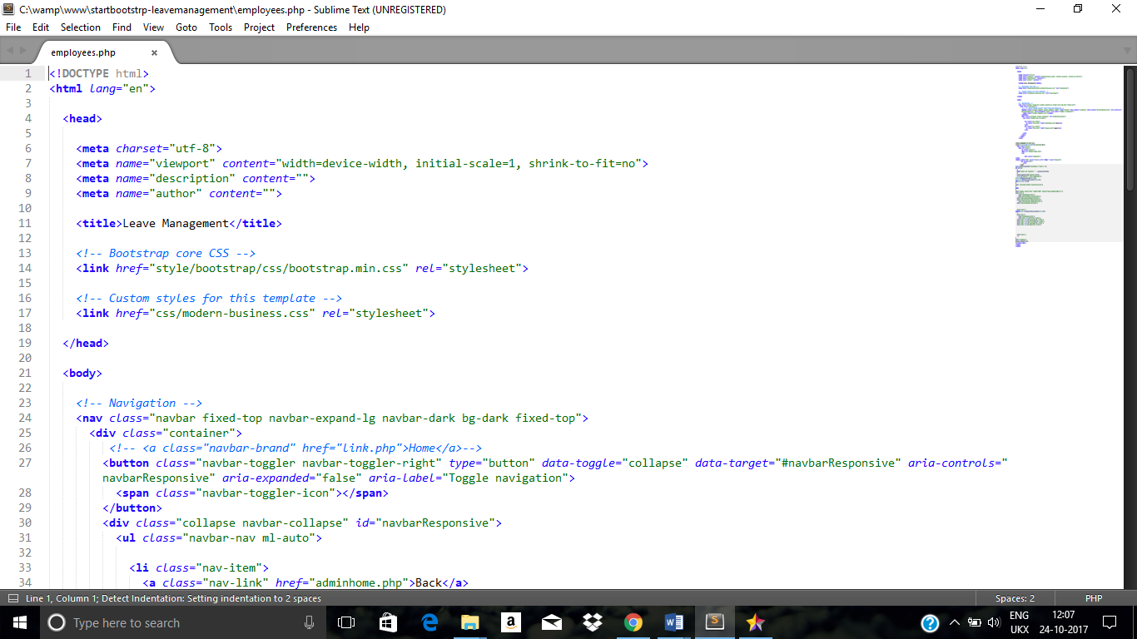

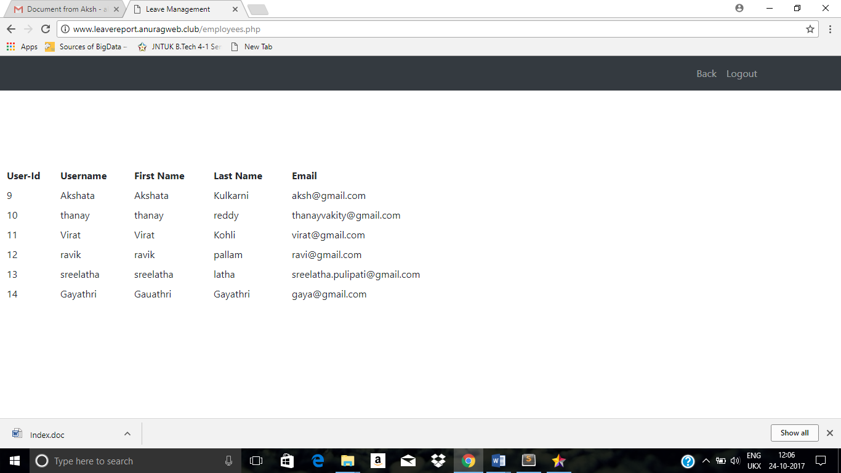

db_connection.php
Parameters :none
This is the database connection for the entire project.
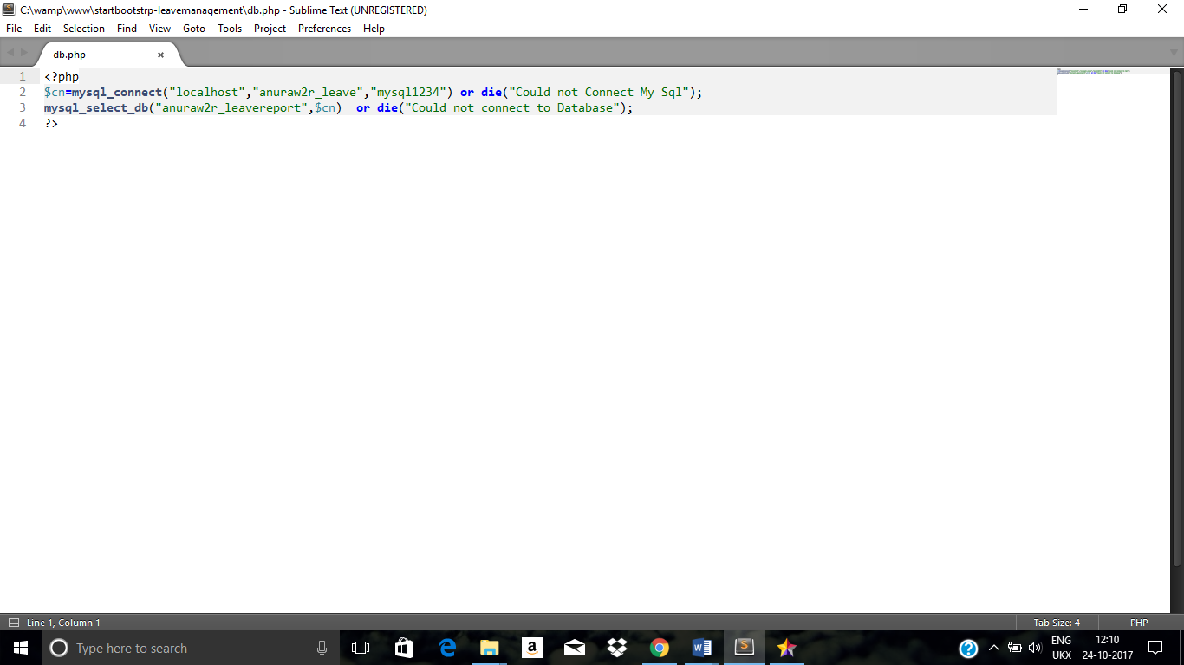

CHAPTER-3
DATABASE/E-R DIAGRAM
E-R DIAGRAM
An entity-relationship diagram (ERD) is a data modeling technique that graphically illustrates an information system's entities and the relationships between those entities. An ERD is a conceptual and representational model of data used to represent the entity framework infrastructure.
E-R DIAGRAM OF THE SYSTEM

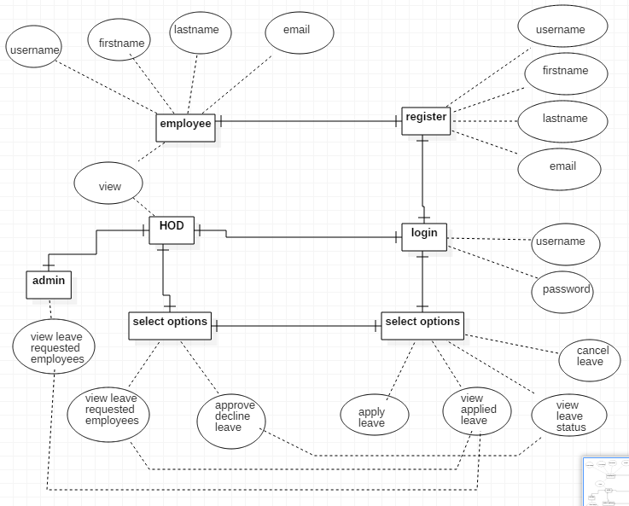
Fig.3.1.E-R Diagram

DATABASE TABLES
The database includes the following tables.
- Employees
- Hod
- Admin
- Leave apply
- Leave cancel

Employees
Name | Datatype
id | int
username | varchar
firstname | varchar
lastname | varchar
password | varchar
email | varchar

Table3.1.Employee Table

Hod
Name | Datatype
id | int
loginid | varchar
password | varchar

Table3.2.Hod Table

Admin
Name | Datatype
id | int
loginid | varchar
password | varchar

Table3.3.Admin Table

Leaveapply
Name | Datatype
id | int
apid | int
apname | varchar
total leave | varchar
leave taken | varchar
Balance day | varchar
Date applied | varchar
dfrom | varchar
dto | varchar
leavetype | varchar
Contact no | varchar
reason | varchar
Verified by | varchar

Table3.4.User Table
Leave cancel

Name | Datatype
id | int
apid | int
apname | varchar
Date applied | varchar
Cancel from | varchar
Cancel to | varchar
Approved by | varchar
reason | varchar
status | varchar

Table3.5.User Table

CHAPTER-4
TEST CASES
INTRODUCTION
A test case is a software testing document, which consists of event, action, input, output, expected result and actual result. Test case defined as test case is an input and an expected result. It can occasionally be a series of steps.
TESTCASES IN PROJECT
Test Case Id | Test Case | Function being tested | Initial state | Input | Expected output | Status
1 | Welcome page | Opening home page | Power on | URL | Home page | Success
2 | Registration | Accept details | Home page | Enter details | Registration successful | Success
3 | Login | Verify username, password | Home page | Enter details | Login successful | Success
4 | Apply, View applied leave, status | Leave application and viewing applied leave | Welcome page | Enter Details | Applied and retrieved successfully | Success
5 | Approve Reject Leave | Approve/Reject the details | Welcome page | Approve/reject buttons | Successfully approved/rejecte-d | Success
6 | Logout | Logging out of the site | Welcome page | Clicking logout | Out of site | Success
Table.4.1.Testcases
CHAPTER-5
DEPLOYMENT

DEPLOYMENT DIAGRAM
A deployment diagram in the unified modeling language models the physical deployment of artifacts on nodes. To describe a web site, for example, a deployment diagram would show what hardware components (“nodes”) exist (e.g., a web server, an application server, and a database server), what software (“artifacts”) run on each node (e.g,. web application, database ), and how the different pieces are connected.
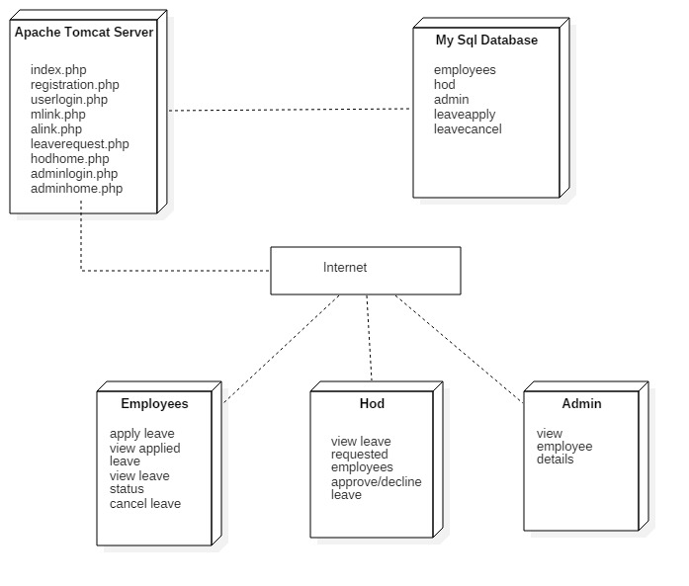
Fig.5.1.Deployment Diagram

CHAPTER-6
CONCLUSION
6.1 PROJECT CONCLUSION
Online Leave Management System website is completely tested and observations results success. So the application is working in according to the aim of the project.
6.2 FUTURE ENHANCEMENTS
User interface components can be made more attractive and user friendly. The leave applying can be made easier, in future we can use biometric to record the authorized employees id’s and also he/she can get the details of his/her leave application details to their mobile numbers.
The HOD can use this biometric authorization of employees to even calculate their number of working days in college and the leaves to be granted to them.

BIBILIOGRAPHY:

FOR PHP
- PHP5 and MySQL by W Jason Gilmore (Apress)
- PHP Web Development by Allan Kent and David Powers (Apress)
- Professional PHP4 by Christopher Scollo
- PHP 5 Unleashed by John M. Coggeshall
- Advanced PHP Programming by George Schlossnagle
- Programming PHP by Kevin Tatroe
- Zend PHP Certification Study Guide by Zend Technologies

FOR MySQL
- MySQL (2nd Edition) (Developer's Library) by Paul Dubois
- Php and MySql---Larry Ullman

FOR JavaScript
- http://www.w3schools.com/
- http://www.zend.com/php/beginners/
- http://www.devshed.com/c/b/PHP/
- http://www.phpfreaks.com/

